THEORY QUESTIONS
1.
a

In a class of 30 girls, 17 play football, 12 play hockey and 4 play both games.
i

Draw a Venn diagram to illustrate the given information.
ii

How many girls play:
α

one or two of the games;
β

none of the two games?
b

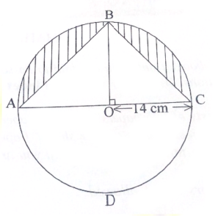
In the diagram, ABCD is a circle of radius 14 cm and centre O. Line BO is perpendicular to line AC. Calculate, the total area of the shaded portions.
[Take π =
22
7
]

2.
a

Two consecutive odd numbers are such that seven times the smaller, sutracted from nine times the bigger, gives 144. Find the two numbers.
b

A paint manufacturing company has a machine which fills 24 tins with paint in 5 minutes.
i

How many tins will the machine fill in
α

1 minute, correct to the nearest whole number?
β

1 hour?
ii

How many hours will it take to fill 1440 tins?
c

Given that s =
n
2
[2a + (n - 1)d], a = 3,d = 4 and n = 10, find the value of s.

3.
a

Using a rule and a pair of compasses only, construct:
i

a triangle ABC with |BC| = 9 cm, |AC| = 8 cm and |AB| = 6 cm;
ii

the perpendicular bisector of line BC;
iii

the bisector of angle ACB.
b

Label the point of intersection of the two bisectors as Y.
c

Draw a line to join B and Y.
d

Measure:
i

|BY|;
ii

|YC|;
iii

the base angles of triangle BYC.
e

What type of triangle is BYC?

4.
a

The table below shows the ages of students admitted in a hospital.
Age (years) | 10 | 11 | 12 | 13 | 14 | 15
Number of students | 5 | 1 | 7 | 10 | 3 | 4
Use the information to answer the following question:
i

What is the modal age?
ii

Calculate, correct to two decimal places, the mean age of the students.
b

Rice is sold at GH₵56.00 per bag of 50 kg. A trader bought some bags of rice and paid GH₵1,344.00.00
i

How many bags of rice did the trader buy?
ii

If the trader retailed the bags of rice at GH₵1.40 per kg, how much profit was made on 1 kg of rice?

5.
a

Using a scale of 2 cm to 1 unit on both axes, draw on a graph sheet two perpendicular axes 0x and 0y for -5 ≤ x ≤ 5 and -5 ≤ y ≤ 5.
i

Plot, indicating the coordinates of all perpendicular points A(2,3) and B(-3,4). Draw a straight line passing through the points A and B.
ii

Plot on the same graph sheet, indicating the coordinates of the points C(4,2) and D(-2,-3). Draw a straight line passing through the points to meet line AB.
b

Using the graphs in (a):
i

find the values of y when x = -2;
ii

measure the angle between the lines AB and CD.

6.
a

If m =
(
2x + 1
2 - 3y
)
, n =
(
6
-8
)
and (m + n) =
(
9
-12
)
, find the:
i

values of x and y;
ii

components of m.
b

i

Solve the inequality:
3
4
(x + 1) + 1 ≤
1
2
(x -2) + 5.
ii

Illustrate the answer in b(i) on a number line.
c

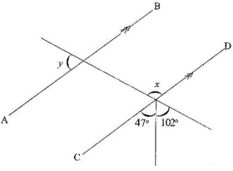
In the diagram, AB is parallel to CD.
Find the value of:
i

x;
ii

y.

